**Thư mời**

Một số cấu trúc

**I am writing this letter to invite you to**

**I would like to ask you to come ….**

* **I wonder if you would like to come …..**
* **I would like to invite you to …………….a dinner/ to V**
* **We are planning to …..**
* **We would be happy if you could come.**
* **I cordially/ sincerely invite you to join us**
* **Please accept my invitation**

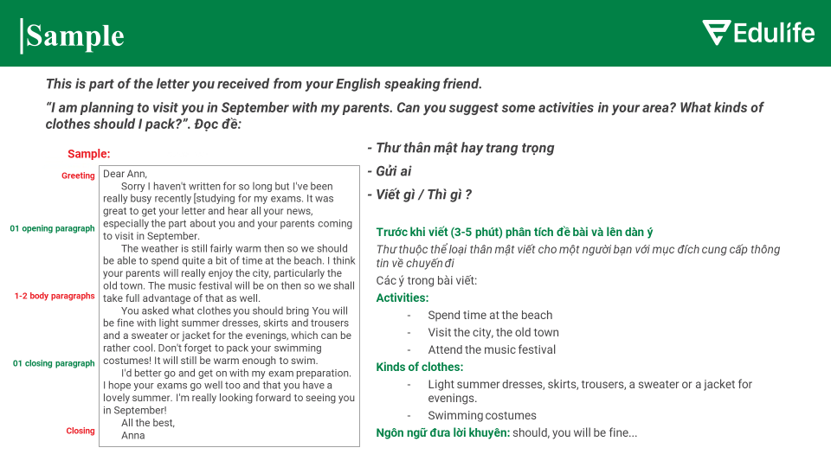

INVITATION LETTER 1

|  |
| --- |
| ***Your English friend who you met while you studied in the UK is coming to Hanoi for an International conference. You want to invite him to Ho Chi Minh for a short visit.***  ***Write a letter to him to invite him to Ho Chi Minh city.*** |

Dear ………….,

I am very glad to know that you are going to take part in an international conference in Hanoi.

**I am writing this letter to invite you to** come to HCM city to see us after the conference.

I have talked about you to my parents and they also want to see you. We have moved into a big flat with 4 bedrooms. You can stay with us when you are in HCM city. My parents and I are willing to be your guides. I will take you to visit famous places of interests in HCM city such as the Reunification Palace, the Notre Dame Cathedral, Ben Thanh Market.

Before you come, please give us a call. My telephone number is ……. I will welcome you at the airport.

Please do come, we look forward to your arrival.

All the best,

Peter

INVITATION LETTER 2

|  |
| --- |
| ***You are planning a trip to Australia during the Spring Festival and you want to invite an old friend to join the trip.***  ***Write to your friend on the matter*** |

Dear Mary,

I am sorry that I haven’t written to you for a long time because I am busy with my work/with my study/ my exams.

I know that you are in good health/ you are getting on well with things.

I am writing this letter to invite you to join a trip to Australia. As you know, the Spring Festival of this year is coming and we are having a plan to join a tour to Australia at that time. Some of our friends are going.

Would you like to join us? You know, it is very warm and a bit sunny in Australia around that time. So, it is possible that we could spend time on beautiful beaches in that country. Moreover, we would have many opportunities to visit some nice places. Also, there are so many beautiful flowers in the country and during the Spring Festival; therefore, all of us will take a number of good photos.

Please let me know if you can go with us. I do hope that you can arrange your work so that you can take part in this trip.

+ I am always happy to hear from you, so please write again soon!

+ I am looking forward to hearing from you soon.

Best Wishes,

Ký tên nước ngoài

**Cấu trúc bài viết thư mời:**

**1. Lời chào: Dear Name/Mr. /Mrs. (nếu biết rõ tên) hoặc Dear Sir/Madam/Sir or Madam/Department** (*nếu không có thông tin cụ thể*)

**2. Mở bài:** Gửi lời chào và lời mời

Lovely to hear from you: *Rất vui khi nhận được tin tức từ bạn.*

**How are you?: Bạn khỏe không? - thư thân mật**

**How are things?: Mọi việc thế nào?**

Hope you’re well: *Tôi hi vọng bạn khỏe.*

**I’m so pleased/glad to hear that**…: *Tôi rất vui khi biết rằng…*

It’s great to hear that…: *Thật vui khi biết rằng…*

**I sincerely invite you to**…: *Tôi chân thành mời bạn tới…*

**I would like to invite you to** come to my house: **trang trọng**

I would like to **ask** you to come …: *Tôi muốn mời bạn tới…:* **thân mât**

**I am writing this letter/ email to invite you to……:**

**3. Thân bài:** Nêu thông tin **chi tiết về lời mời**

**We are planning to**…: *Chúng tôi đang định…*

On (date), at (time), I plan to have…: *Vào (ngày), vào lúc (giờ), tôi dự định có…*

The party will take place at (time), on (date), at/in (place): *Bữa tiệc sẽ diễn ra vào lúc (giờ), vào (ngày), tại (địa điểm).*

**4. Kết bài:** Nhắc nhở **chấp nhận lời mời và gửi lời cảm ơn**

**Please accept my invitation:***Hãy chấp nhận lời mời của tôi. Hoac* **Please do come : hãy đến nhé**

**We would be very happy if you could come to join us:***Chúng tôi sẽ rất hạnh phúc nếu bạn có thể tới tham gia với chúng tôi.*

**I should be cheerful if you could come to**…:*Tôi sẽ rất vui nếu bạn có thể tới…*

I **look forward to** your arrival/ **attending**: *Tôi mong sự ghé thăm/sự tham dự của bạn.*

**5. Kết thúc: Yours faithfully,** (*Kính thư*) nếu chưa quen biết người nhận, **Yours sincerely,** (*Kính thư*) nếu đã quen biết người nhận. Ngoài ra, có thể dùng **Yours truly, Yours respectfully,** (*Kính thư*) hoặc **All the best, Best wishes, Best regards,**(*Chúc mọi điều tốt lành*)

**Ký tên: Ko kí tên thật vì là đi thi.**

**Một số cấu trúc**

* I would like to ask you to come …. (thân mật)
* I wonder if you would like to come …..trang trọng
* I would like to invite you to a dinner
* We are planning to …..
* We would be happy if you could come
* I cordially invite you to join us: thân mật
* Please accept my invitation/ * trang trọng
* Please do come - thân mật